1. **Identify and describe typical components of a thunderstorm cloud, and describe the nature and�evolution of cells in different types of thunderstorms**
   1. **Orographic Thunderstorms**
      1. **Mountains** can also trigger thunderstorms, when horizontal winds are forced upslope, and push the boundary layer air up through the capping inversion
   2. **Multicell Storms**
      1. There is a flanking line of clouds sticking out from the main updraft. In this **flanking line** are often the new cells still in the cumulus stage. As they grow, the prevailing winds blow those cells into the main updraft, by which time the cells are often in the mature stage
   3. **Squall Lines**
      1. special type of multi-cell storm where the heaviest rain cells merge into a long narrow line
   4. **Air Mass Thunderstorms**
      1. pop up in scattered locations within a large air mass due to strong heating of the ground by the sun
   5. **Supercell Storms**
      1. Wind shear is when the wind speed or direction changes with altitude. In the case of supercell storms, there is often low altitude flow from the southeast, mid-altitude flow from the southwest, and fast upper-level flow is from the west.
2. **Identify mammatus clouds, flanking lines, cloud striations, haboobs, arc clouds, wall clouds**

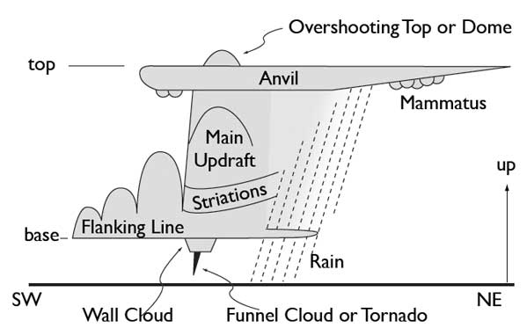

This rotation is called a **mesocyclone**, and is often visible to the eye by the barrel-shaped appearance of the outside of the storm. Sometimes, as a result of this rotation, there are **cloud striations** (like the grooves on a screw) that spiral around the main updraft clouds.

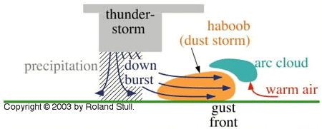

1. **Identify atmospheric layers and explain how they relate to storms**

The whole atmosphere, as well as the storms within it, ultimately gets their energy from the Sun.

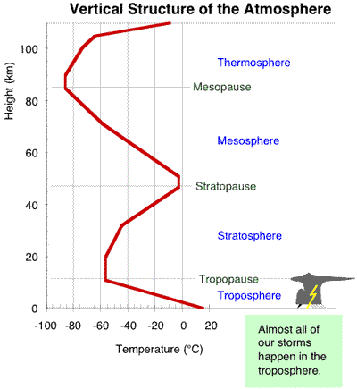

But when that sunlight reaches the ground, some of its energy can be consumed evaporating liquid water from the oceans, lakes, rivers, vegetation, and soil. This portion of energy from the sun is hidden as **latent heat** in the water vapour! The remainder (minus a small portion that is conducted into the ground) goes into **sensible heating** of the air.

These two heat sources are the fuel for storms. We quantify (or measure) these heat sources by air temperature and humidity, respectively. Thus, **TEMPERATURE and HUMIDITY are very important when studying storms**.

1. **List and describe the storm hazards and disaster scales covered in this course**
   1. **Enhanced Fujita scale**
      1. **Tornado intensity** in North America based on the amount of damage to buildings
      2. classification by the Enhanced Fujita scale is possible only after the tornado has occurred
      3. scale ranges from **EF0** through **EF5**. **EF5** is an exceptionally strong tornado that can totally destroy whole buildings, and **EF0** is a very weak tornado that might break a few windows. Although **EF6** and greater tornadoes are possible, they are impossible to determine from damage estimates because they all cause the same total destruction as an **EF5** tornado.
   2. **Torro Scale**
      1. Used in Europe and determined by wind speed
      2. Scale T0 to T10
   3. **Saffir-Simpson Hurricane Scale**
      1. categorizes hurricanes based on the wind speed on scale from 1 to 5
2. **Name and describe the characteristics and hazards of the 3 main types of supercell thunderstorm**
   1. low precipitation (LP)
      1. prolific hail producers
   2. classic
      1. varying degrees of hail size, tornado strength, and strength of straight-line wind
   3. high precipitation (HP)
      1. prolific producers of lightning
3. **Use weather radar and satellite to identify and predict storm characteristics**

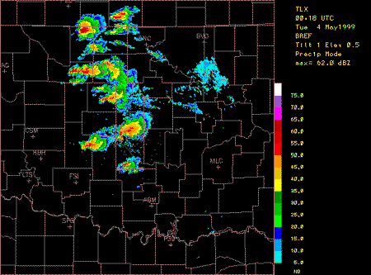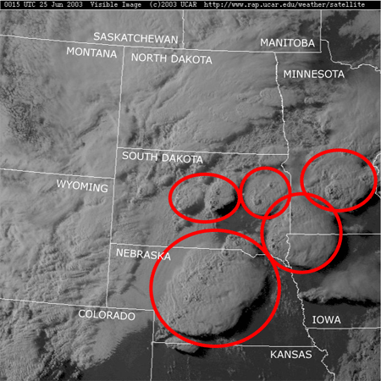

Weather **radar** transmits a beam of microwaves into the atmosphere, and "listens" for the faint echo of microwave energy that bounces back off of raindrops. Heavier rain causes a stronger echo, which is often coloured as yellow and red on radar displays. The lighter rain is shown with the blues and greens.

On visible **satellite photos** of thunderstorms, you can often see the shadow of the thunderstorm anvil that is cast on the lower clouds or on the ground. The anvils (marking the tops of thunderstorms) in the satellite image below are circled in red

1. **Explain how humidity, saturation, latent heat, advection, and adiabatic cooling affect storm energy**

**Saturation**: maximum amount of water vapour that air can carry at equilibrium. Because saturation is so important in determining whether condensation occurs and latent heat is released into the thunderstorm. Saturation value is so important in controlling atmospheric humidity

**Humidity**: A quantity representing the amount of water vapour in the atmosphere or in a gas. Latent heat, which is hidden in water; measured using humidity

**Latent Heat**: The sneaky aspect of this process is that sensible heat can be consumed to evaporate water in one location, but the water vapour can be blown by the wind to a different location such as a storm. When it condenses in this new location, it heats the storm. This is one of the major ways that storms get their energy -- through water vapour that is drawn into the storm and then condenses to release its latent heat. Thus, movement of water vapour causes movement of energy (heat).

**Advection**: Not only can warm air be moved about by the wind and storm circulations, but so can humid air. Such movement of heat and humidity by the wind is generically called **advection.**

**When some of the water vapour in humid air condenses, latent heat is released and converted into sensible heat, thereby increasing the air temperature. The net result is that the Sun's energy can be drawn into storms by two mechanisms (figure below): advection of heat (temperature), and advection of moisture (humidity).**

**Adiabatic Cooling:** air cools as it rises, latent heat released to warm storm

1. **Explain how solar energy can get into the atmosphere to power storms**

Solar energy is transported by radiation, which heats the ground, which heats and adds moisture (red and green arrows) into air parcels, which can be blown (advected) into storms, where the energy is released to power the storm.

1. **Describe different types of lightning, and explain the sequence of events in a lighting strike**
   1. **cloud-to-cloud (intercloud, IC)**
   2. **cloud-to-ground (CG)**
      1. further classified by whether **negative** or **positive** charge moves to the ground
         1. Negative strikes form from the cloud base and are more numerous
         2. Positive strikes are less frequent, are often much stronger, and form from the thunderstorm anvil

Lightning forms because electrical charges build up in thunderstorms, associated with the freezing and collision of cloud droplets and ice crystals (called **graupeln**). When the electrical potential (i.e., charge difference) between the cloud and ground becomes great enough (a **breakdown potential** of 3 billion volts / km is needed, for every km length of the lightning bolt), the air **ionizes**.

This changes the air from an insulator to a conductor, along that ionized path. This path very rapidly steps down from the cloud, and is known as a **stepped leader**. When it nears the ground **streamers** of electrons rise from tall trees, poles, and buildings to meet the stepped leader. Once they make this connection, closing the circuit, the electrons flow in a massive current (2,000 to 200,000 amperes) called the **return stroke**.

1. **Explain lightning risk: dangerous times and places; how it affects people; and what you can do to�stay safe**

Lightning often ranks in the top two of weather related killers in North America

Dangerous Places:

* + Golfers must be particularly aware of lightning safety, as much as hikers, sailors, and any others who work or play in exposed locations outdoors. Although lightning usually seeks out the highest nearby point to strike (such as a tree, telephone pole, or building), there are other strikes that miss the highest object and strike low lying areas
  + avoid unsafe areas such as small structures, huts, rain shelters, nearby metallic objects (pole, fence), trees, water, open fields, hill tops, etc.
  + If caught in the open, do the "Lightning-Safety Crouch" with feet together, hands over ears

Stay Safe

* + Follow the 30/30 Rule: If **30 seconds** or less between the flash is seen and a bang is heard, then **move indoors** and stay there until **30 minutes after last lightning or thunder**.
  + Stay indoors, or in a metal car with the windows rolled up, during a lightning storm

1. **Explain how forces, acceleration, buoyancy, and pressure-gradients relate to winds**

Warm air wants to rise, thereby creating updrafts. Cold air wants to sink, thereby creating downdrafts. The reason for these vertical motions is that temperature affects the **density** of air, and density affects **buoyancy.**

Pressure tends to push outward in all directions. One air parcel has a pressure, and pushes outward and tries to expand, like when you inflate a toy balloon. However, if there is a change of pressure between one air parcel and its neighbour, then this pressure difference causes a net force called **pressure-gradient force**.

1. **Describe how heat released in the atmosphere can create vertical and horizontal winds**

Fewer molecules in the core causes lower pressure at the surface (as shown in the figure below), because pressure is the weight of all the overlying air. This low pressure at the bottom of the core creates a pressure gradient that sucks in air. This gives the spiral inflow into the bottom of a hurricane. This inflow advects in more fuel (warm humid air), making the hurricane stronger.

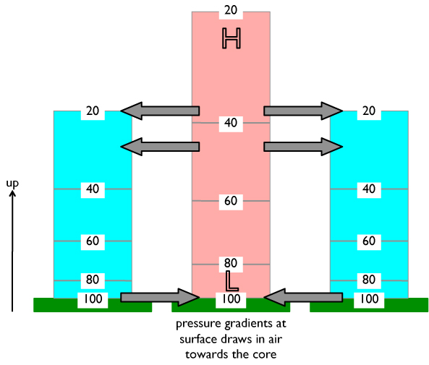

1. **Explain how the continuity affect ties vertical and horizontal winds into circulations**

**Continuity:** air molecules tend to spread themselves smoothly and evenly, and don't leave any gaps

The air parcel is rising because of its buoyancy, and there is a circulation of the surrounding environmental air out of the way above the parcel, and filling back in under the parcel

1. **Identify downbursts and gustfronts, describe how they form and look, and what their hazards are**

Downbursts:

* 1. regions of rapidly descending air
  2. caused both by falling rain that drags some air down with it, and by the evaporation of some of the rain as it falls, which cools the air
  3. often invisible but are a hazard to aircraft, especially just after takeoff or just before landing

Gust Fronts:

1. downburst hits the ground, the air spreads outward to create violent **straight-line winds** that can be a hazard to mobile homes
2. leading edge of this cold, spreading air is called the **gust front**
3. If this gust front blows over dry dusty surfaces, it can pick up lots of dust to become a dust storm or sand storm called a **haboob**
4. In humid regions, the advancing gust front can push the surrounding warm, humid air upward to create a cloud called an **arc cloud**
5. These winds can blow down large trees and destroy weak structures such as mobile homes and out-buildings. They are also a hazard to aircraft during take-off and landing
6. **Describe hail hazards, locations and times of greatest risk, and appropriate safety procedures**

**Location**: are most common with supercells (low precipitation storms)

**Hazards:**

1. injury or death
2. dents in metal cars
3. broken windows (sending shards of glass to your eyes)
4. crops are flattened
5. livestock can be injured or killed

**Appropriate Safety Procedures**:

1. get indoors
2. if in a car, make a U-turn to leave the hail area, or park under a roof
3. if car is exposed to strong hail, pull over to the side of the road and park; close your eyes to keep glass shards out.
4. **Describe tornado shapes, what makes them visible, and where they form relative to a thunderstorm**

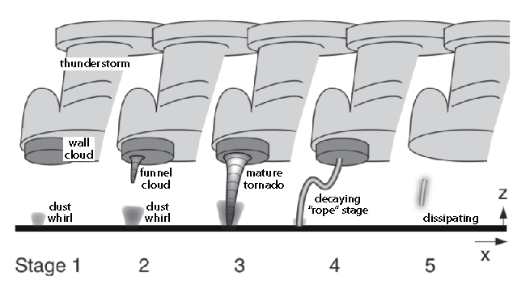

Early in its life cycle, a funnel cloud (an actual cloud made of water droplets) may not yet be visible, but the rotation could be already started and kicking up some dust and debris. Later, if the tornado continues to strengthen, the rotating funnel cloud grows down from the base of the thunderstorm, and merges with the debris cloud from the ground. Near the end of the life cycle, tornadoes often decrease into a "rope" stage, where they are long, thin and bent or twisted.

**Most tornadoes are made visible by cloud-water droplets** (the **funnel cloud**) **and/or by dust and debris from the ground** (the **debris cloud**). Some tornadoes are invisible.

An isolated lowering of the cloud base, beneath the rising cumulus towers on the southwest flank of the storm, is called a **wall cloud**. This is usually outside of (SW of) the precipitation region of the cloud. Wall clouds in supercells sometimes rotate, and it is from these rotating wall clouds that tornadoes form.

1. **Use photographs & videos to identify the tornado intensity on the enhanced Fujita scale**

**EF0**: windows broken;  
**EF1**: windows and minor roof damage;  
**EF2**: roof almost totally destroyed, some exterior wall damage, but most interior wood-frame walls intact;  
**EF3**: roof and many interior and exterior walls destroyed;  
**EF4**: total destruction; all aboveground wood-frame walls destroyed, with the resulting debris littering the lot;  
**EF5**: total above ground destruction of wood-frame building, with most of the debris blown away by the winds. All that remains are the foundations and concrete floor and driveway slabs.

1. **Describe characteristics of tornado evolution, tornado outbreaks, and mesocyclones**



Early in its life cycle, a funnel cloud (an actual cloud made of water droplets) may not yet be visible, but the rotation could be already started and kicking up some dust and debris. Later, if the tornado continues to strengthen, the rotating funnel cloud grows down from the base of the thunderstorm, and merges with the debris cloud from the ground. Near the end of the life cycle, tornadoes often decrease into a "rope" stage, where they are long, thin and bent or twisted.

When many tornadoes occur during a week or less, the event is called a **tornado outbreak**

**Mesocyclones**: Whole supercell thunderstorms rotate slowly, more likely to cause tornadoes

1. **Explain tornado hazards and safety procedures, and times and locations of greatest risk**

**Safety Procedure**: If caught outdoors on foot with a tornado approaching, find a ditch or hole to get into, to place your body below the "line of fire" of all the fast moving debris blown by the storm. If in a car, just drive away from the tornado on the best convenient road, preferably to the right or left of the translation direction of the tornado. Do not hide under a highway bridge or overpass.

**Locations**: The safest place to be, if a tornado is approaching you, is below ground in a basement or storm cellar. Some new homes in tornado alley are built with a closet designed as a "safe room", made of reinforced concrete walls and ceiling. This can be used as an aboveground tornado shelter if there is no basement.

Mobile homes are particularly vulnerable to thunderstorm and tornadic winds, and are the worse place to be in a tornado. You should immediately evacuate a mobile home if a tornado is approaching, and move to either a substantial permanent shelter, or get into a ditch.

1. **Explain the difference between tornado watches and warnings, and appropriate safety responses**

The best meteorologists can do with a 6 to 12 hour forecast is to give a **Tornado Watch**, which indicates a broad region within which tornadoes are favorable or likely later in the day.

* + - When you hear a tornado watch issued for your area, you can continue your normal activities, but should monitor emergency announcements on the news or weather radio

If a Doppler radar detects a likely tornado (i.e., a **tornado vortex signature** or TVS), or if a human spotter or other government official actually sees a tornado, then a **Tornado Warning** is issued. This is a very short-term forecast (i.e., a **nowcast**) that identifies where the tornado is, and where it is moving.

* + - Warnings come only 15 minutes or less prior to a tornado hitting, so you must **immediately** terminate your normal activities and run to a tornado shelter or other area of refuge.

1. **Describe the anatomy of a hurricane, and how it looks in weather radar and satellite images**

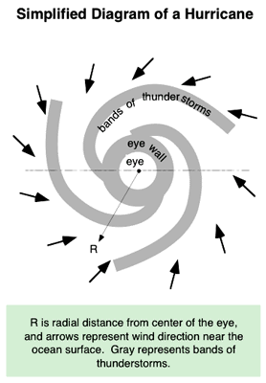

Hurricanes are made up of thunderstorms. Around the relatively-calm **eye** of the hurricane is a ring of thunderstorms called the **eye wall.** From the eye wall are additional bands of thunderstorms that spiral outward, called **spiral bands**.

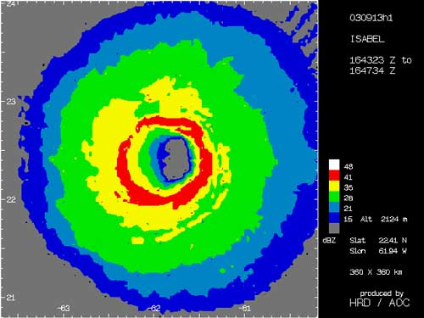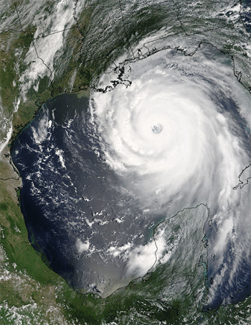

1. **Explain how sea-surface temperature, winds, waves, condensation, and a "warm core" affect�hurricanes**

Low pressure in the eye of the hurricanes sucks boundary layer air into it. As this air gets closer and closer to the eye, it moves faster and faster, as already discussed. Faster winds create larger waves on the ocean surface. Evaporation from the ocean surface, enhanced with spray from the waves, adds significant amounts of moisture into the boundary-layer air. Thus, by the time the boundary-layer air reaches the base of the eye wall, it is warm and exceptionally humid (near 100% relative humidity), and thus contains tremendous amounts of sensible and latent-heat fuel needed by the eye-wall thunderstorms

In order for this process to work, the **ocean surface temperatures** must be **warmer than 26 °C**. Also, these **warm surface waters** must be roughly **60 m deep or more**, so that the turbulent mixing within the ocean caused by the surface waves **doesn't mix up colder waters** to the surface. Such deep, warm layers of ocean water often form in the tropics during summer, where there is maximum heating from the sun. Thus, hurricanes usually occur in **late summer** and in **early Fall**, when there is maximum extent and depth of warm waters.

The constant supply of thunderstorm fuel (boundary-layer air) continues only as long as:

1. there is low pressure in the hurricane eye to suck in the air to create the large ocean waves (Low pressure is synergistically maintained by the thunderstorms that make up the hurricane, as is described in the next subsection.); and
2. the hurricane remains over the warm ocean

If the hurricane moves either over colder water or over land, then it cannot generate sufficient warm, humid air to serve as fuel, and the hurricane weakens and dies (see figures below).

1. **Describe the evolution and movement of hurricanes, and locate times and places of greatest risk**

We must be aware of these limitations and understand that there will always be uncertainty in extreme weather predictions until the event, the hurricane, gets close to shore.

Over the Atlantic Ocean, hurricanes that form in this latitude belt are steered by winds blowing around the semi-permanent **Bermuda High** (see figure below). This circulation blows incipient hurricanes from off the west coast of Africa toward the Caribbean, the Gulf of Mexico, and Florida. A large Bermuda High circulation turns the storms more northward near the East Coast of North America. As a result, hurricanes strike the Gulf Coast States and SE Coastal States.

1. **Explain the main hazards of a hurricane and appropriate safety procedures**

What can you do to keep yourself and your family safe from hurricanes? Here are two preventative recommendations:

* Don't buy or build houses on or near the beach in southeastern USA
* Plan in advance for evacuation. Do NOT even think that you can "ride out the storm”

1. **Describe the nature and skill of hurricane forecasting, and explain why Canada has few hurricanes.**

We must be aware of these limitations and understand that there will always be uncertainty in extreme weather predictions until the event, the hurricane, gets close to shore.

* 1. The sea surface temperature is not static. In fact, the warm sea surface shifts with the seasons. Click on the link below to watch an animation of the annual changes in sea surface temperature. Watch for regions where ocean surface temperatures > 26 °C (shown in orange, red, and white here):
  2. In addition to warm surface waters, hurricanes need to extract rotation from the Earth's rotation. At the equator this effect, known as the **Coriolis effect**, is zero; hence, hurricanes cannot form and cannot cross the equator. The Coriolis effect increases as you move away from the equator. Thus, hurricanes are most likely to form between **latitudes of 10 degrees and 30 degrees**, where there is **both warm sea-surface temperature** and **non-zero Coriolis force**.